ELIF: ELIF is the keyword used for the ELSE IF statement in bash scripting. If in a loop if more than two conditions exist which can not be solved only by using IF-ELSE statement then ELIF is used. Multiple ELIF conditions can be defined inside one if-else loop.

**ELIF syntax:**

if [ condition1 ]

then

statement1

elif [ condition2 ]

then

statement2

elif [condition3 ]

then

statement3

else

statement_n

fi

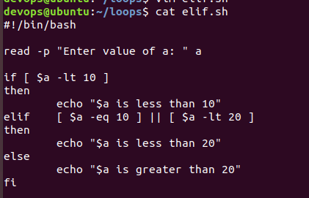

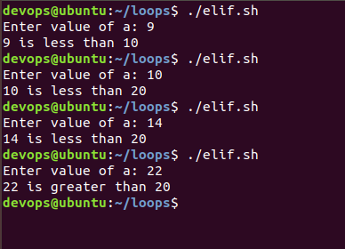

2. Create a user case for string equality.

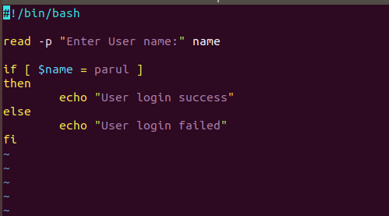

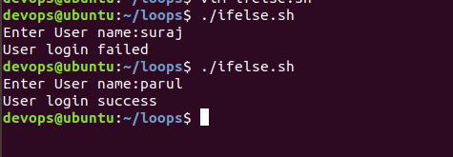

3. Create a user case for logical AND operator

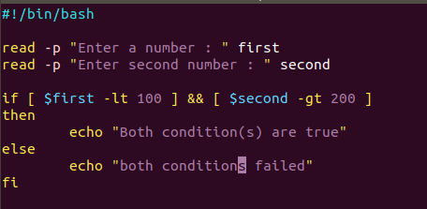

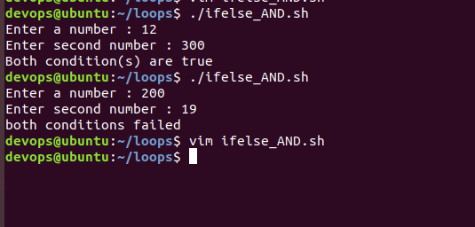

Create a user case for logical OR Operator

